**MYTHIC**

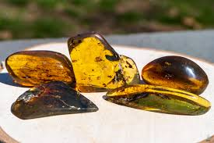

**Name:** Flower Diamond

**Brand:** Steuben Glass

**Model#:** 001

**Color:** Green

**Price: $50 million**